Argel Joseph V. Dela Cruz

BSIT-3A

Windows 8

Windows 8, [code-named](https://www.computerhope.com/jargon/c/codename.htm) Midori, is a version of [Microsoft](https://www.computerhope.com/comp/msoft.htm) Windows that was released on October 26, [2012](https://www.computerhope.com/history/2012.htm). This iteration contains some of the biggest changes Microsoft has made to their operating system since Windows 95. It features new programming and technology that makes run faster than the previous versions. It also has a more streamlined look and feel. Windows 8 includes a [tablet](https://www.computerhope.com/jargon/t/tablet.htm) interface, called [Metro](https://www.computerhope.com/jargon/m/metro.htm), which is compatible with touch screen displays and stills offers access to the traditional Windows desktop. Below is an example of the new Windows 8 Startscreen, which replaced the [Start button](https://www.computerhope.com/jargon/s/start.htm) and [Start menu](https://www.computerhope.com/jargon/s/startmen.htm).

Advantages:

1. It is optimized for the touch devices. Windows 8 uses the ‘Metro’ interface which is improved for touch screen devices featuring a new ‘Start screen’.
2. It supports the low-power ARM architecture. It has advanced security features such as antivirus capabilities and supports secure boot.
3. It has short boot time. Windows 8 boot time takes less than 8 seconds which is much shorter than its earlier version.
4. There is no need for the PC upgrade to run Windows 8. Any PC which is able to run Windows 7 on it can run Windows 8 and there is no need to upgrade PC.
5. One of the main features of Window 8 is the app platform. Windows Store has a number of apps that are built for Windows 8.
6. Windows 8 also supports Near Field Communications (NFC) printing. A technology which can aid in financial transactions digitally.

Disadvantage:

1. The main disadvantage of Windows 8 is overlapping of Metro and Aero User Interface.  Switching between Metro applications and desktop applications is not user-friendly and creates confusion for the users and the developers.
2. There is no way to turn the home screen tiles into icons. When a number of apps are installed, then the Start screen looks garbled.
3. It is very difficult to swap between different screens. The absence of Alt-Tab function makes it difficult when working with many applications as there is no easy way to switch between programs.
4. Another disadvantage of Windows 8 is the Metro multitasking. In Windows 8, in the Metro interface for tablets, the screen display two applications are lined.
5. Metro interface works well on tablets but the User Interface is not very compatible on the desktop. There is a need of some kill-switch which can turn the Metro UI off.
6. Windows 8 doesn’t support any flash content on Tablet PC. Apparently, it has been done in order to save battery of the Tablet. It also protects our privacy and enhance the security of the Tablet.

How to Install.

1. Select a language, time, and keyboard setting**.** In most cases, the information on this window should already be correct; if you see incorrect information (e.g., the wrong time/region), click the item's drop-down box and select the correct information in the drop-down menu.

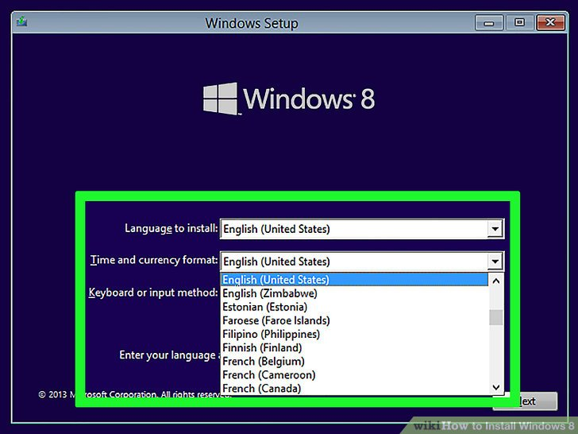

1. Click Next. It's in the bottom-right corner of the window.

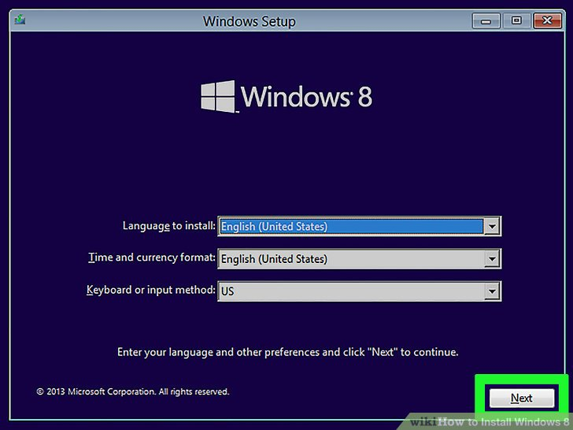

1. Click Install now. This option is in the middle of the window.

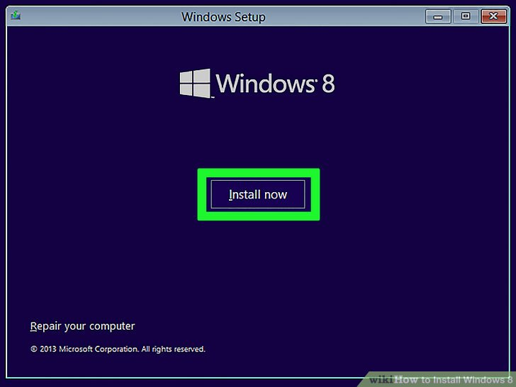

1. Enter your Windows 8 product key**.** Type in the 25-character code that's listed on the Windows 8 CD case, box, or manual, then click Next to proceed.

* If you bought your Windows 8 CD back when Windows 8 came out, you may have a copy of the code in an email in your Microsoft-registered email account.

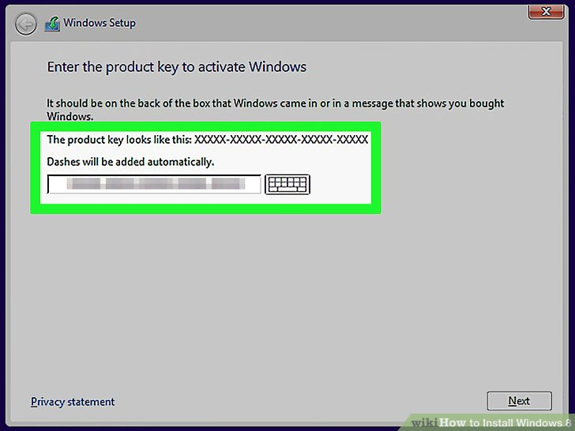

1. Check the "I accept" box. It's near the bottom of the window.

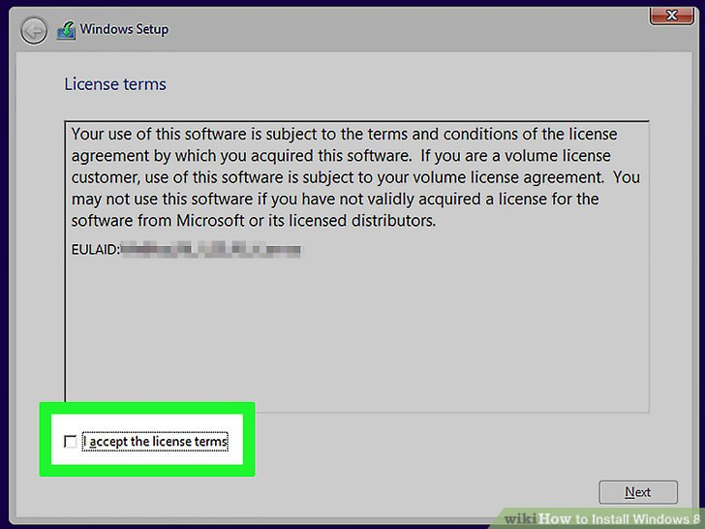

1. Click  Accept**.** This option is in the bottom-right corner of the window.

You may instead click have to click **Next** here.

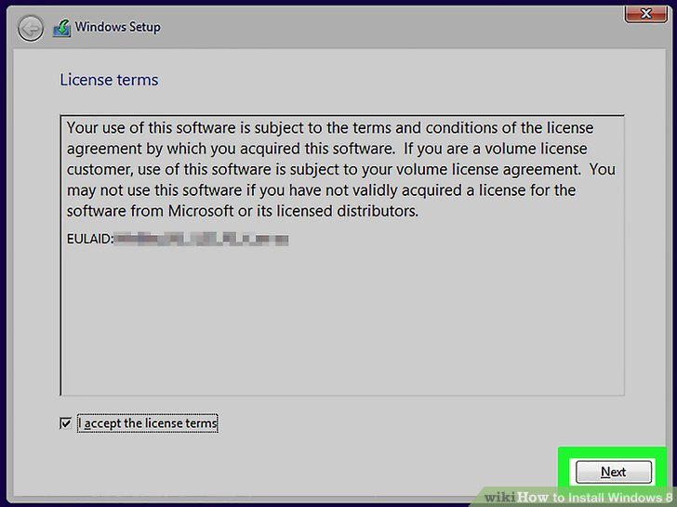

1. Click Custom Install Windows only**.** It's an option on the "Which Type of Installation do you Want" screen.

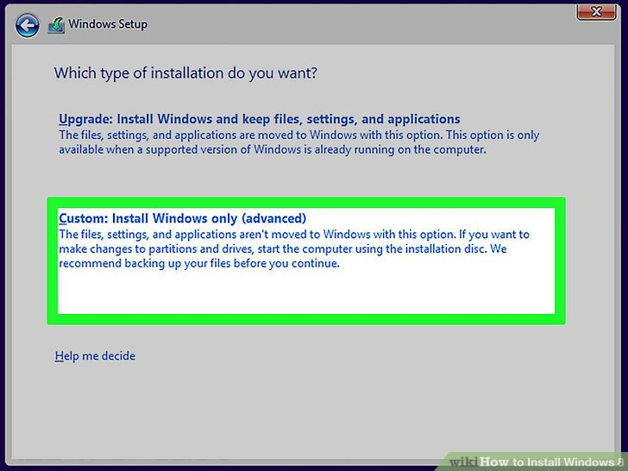

1. Click Drive options (advanced). You should see this option near the middle of the page.

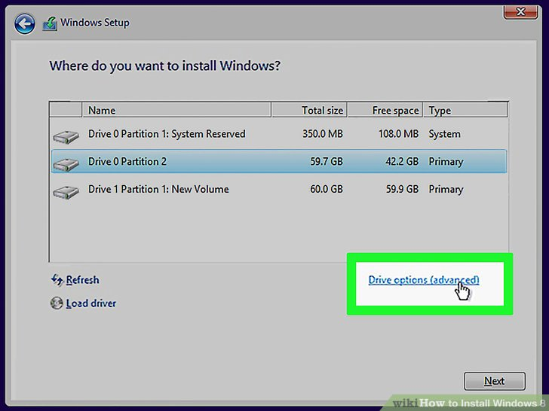

1. Delete the existing information**.** In the window near the top of the page, click a drive name, then click Delete and confirm the decision if prompted. Repeat this process for all drives listed.

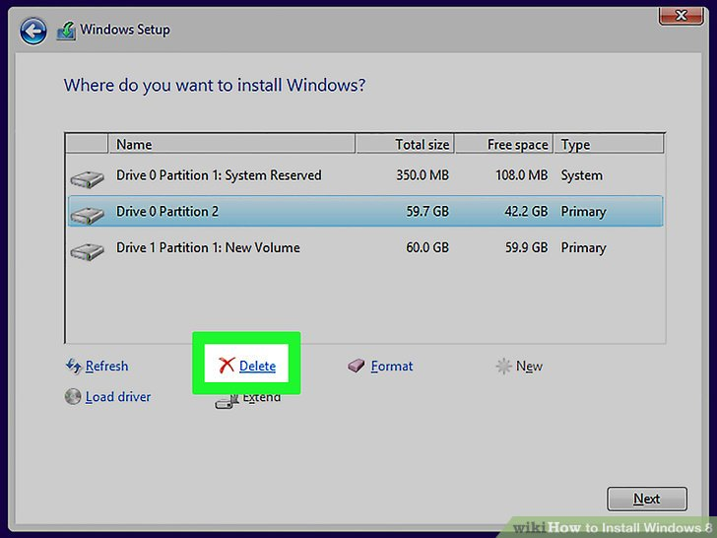

1. Click Unallocated space**.** This should be the only option in the window near the top of the page.

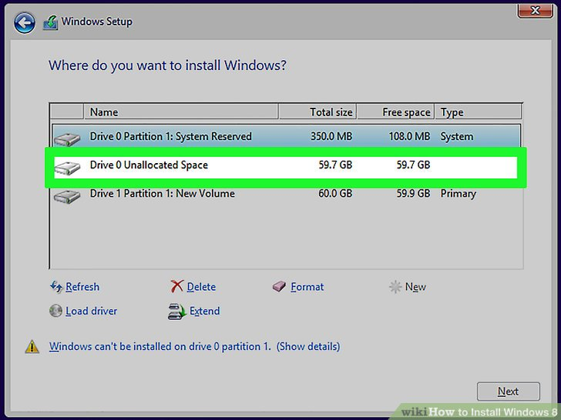

1. Click New**.** It's near the bottom of the page.

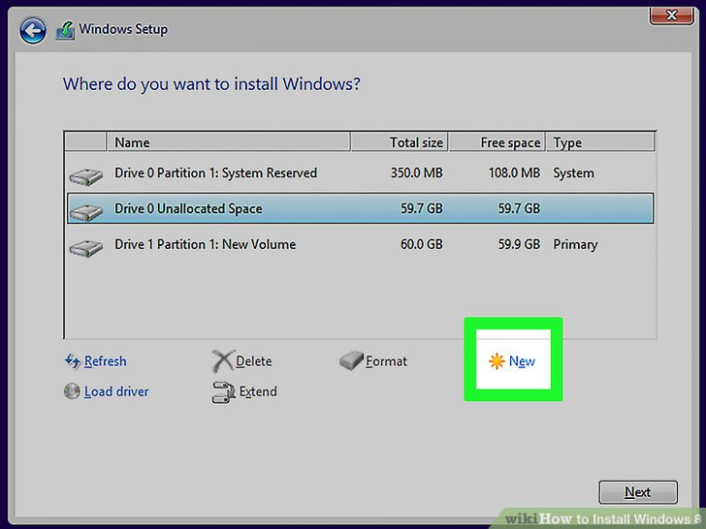

1. Click Apply, then click Next. Both buttons are at the bottom of the page. Doing so will confirm your installation location and begin installing Windows 8 onto your computer.

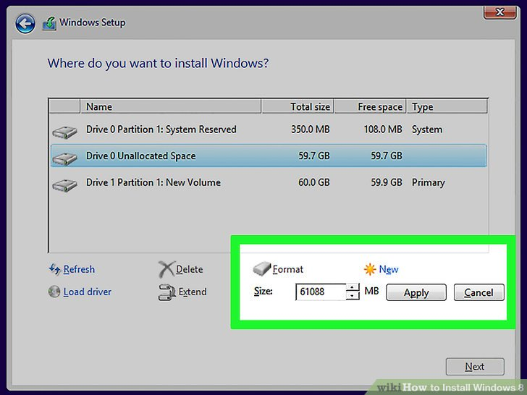

13. Wait for Windows 8 to finish installing**.** Your computer will restart multiple times during the installation process. Once Windows 8 is done installing, you should be at the login screen.

* You may be prompted to do some personalization work (e.g., selecting a theme and color) before you can continue to use Windows 8.

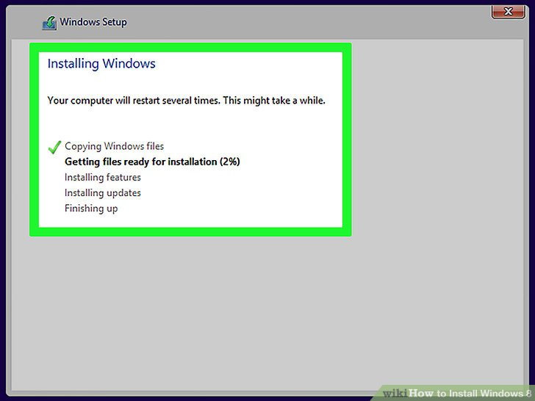

Conclusion.

For anyone familiar with Windows 8, making the jump across to Windows 8.1 will be a painless experience, and while there are plenty of changes under the bonnet, we’re going to focus on all the newest, most useful ones here. You’ll still find the same general way of navigating, and key ‘Charms’  (Search, Share. Start, Devices, Settings) just a swipe away on the right side of the screen. Swiping from the left still cycles you through apps and swiping up from the bottom usually brings up additional options for whichever app you are using. Naturally, all of this only applies when using it in Windows 8 mode, rather than the desktop – there it’s business as usual.